Types of Resistors, Inductors and Capacitors and their applications

Shashank Nandan
IEEE SBM
Manipal Institute of Technology
Karnataka, India
shashanknandan21@gmail.com

Abstract—Passive electronic components, such as resistors, inductors, and capacitors, form the fundamental building blocks of electronic circuits. Each component type serves a unique purpose, from controlling current to storing and releasing energy. This paper explores the various types of resistors, inductors, and capacitors, detailing their construction, characteristics, working principles, and applications in modern electronic circuits. The classification of these components is emphasized, providing insights into their suitability for specific applications, such as power systems, signal processing, and energy management.
Keywords—Resistors, Inductors, Capacitors, Passive Components, Applications, Classification

Introduction
Resistors, inductors, and capacitors are essential components in any electronic system. They manage energy, regulate signals, and ensure the stability of circuits. Each type of component is available in a variety of forms to suit different operational requirements, such as precision, power handling, and environmental tolerance.
This paper classifies and examines these components, providing a detailed overview of their working principles, types, and real-world applications. A comprehensive understanding of their properties and roles ensures optimal design and implementation in electronic systems.

Resistors

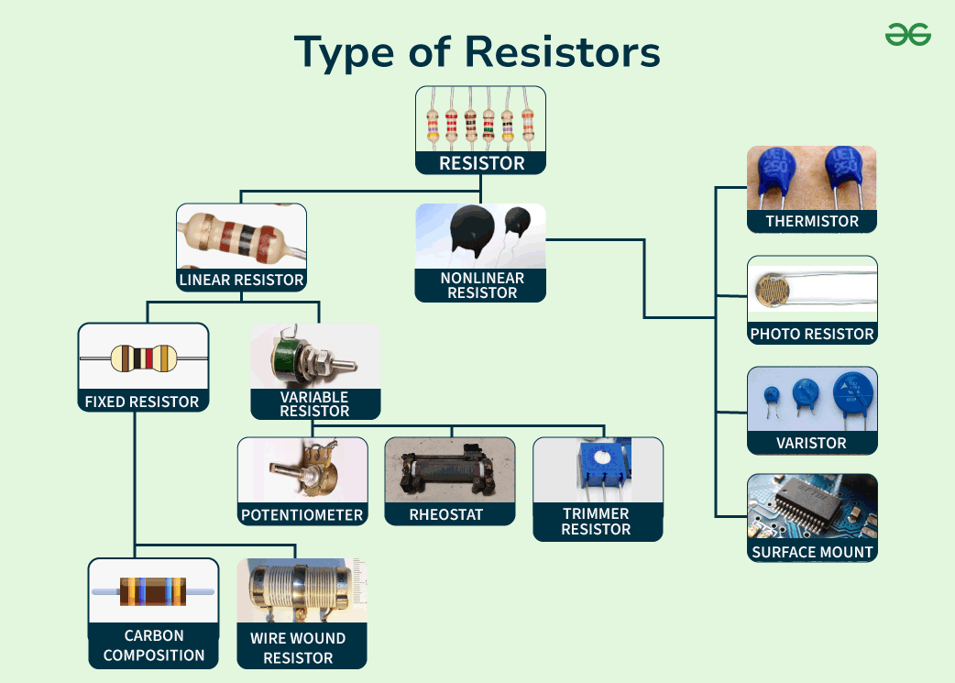
Definition:
Resistor is a passive two-terminal component that opposes the flow of electric current in a circuit. It converts electrical energy into heat by limiting the current, according to Ohm's Law, which states: V=I×R
Where: V is the voltage across the resistor (in volts), I is the current through the resistor (in amperes), R is the resistance (in ohms, Ω).
Resistors are used for controlling current, dividing voltage, and protecting circuit components from excessive current. These are found in almost every electrical/electronic device for purposes like signal processing, biasing components, and setting time constants in circuits. Resistors are classified into 3 types linear, non-linear and special. Further, Linear is classified into Fixed and Variable.

Classification of Resistors
1. Fixed Resistors: These resistors maintain a constant resistance. Carbon film, metal film, and wire-wound resistors are common examples. Carbon resistors are widely used in low-power applications due to their affordability, while metal film resistors offer precision in circuits requiring stability. Fixed can be further classified into:
A) Carbon Film Resistors: Made of a carbon film deposited on a ceramic substrate. Used in general-purpose circuits due to their cost-effectiveness and stability [1].
B) Metal Film Resistors: Feature a metal oxide layer, offering precision. Used in high-precision circuits, such as instrumentation amplifiers [2].
2. Variable Resistors: These allow resistance adjustment, useful in volume control and calibration applications. This is mainly seen in:
A) Potentiometers: Allow manual adjustment of resistance. Used in volume controls and tuning circuits [3].
B) Rheostats: High-power variable resistors used in Motor speed control and light dimming [4].
3. Special Resistors: Thermistors, which vary resistance with temperature, and photoresistors, which are light-sensitive, serve specialized purposes in sensors and thermal protection systems.
A) Thermistors: Resistance changes with temperature Used in temperature sensing and protection circuits [5].
B) Photoresistors (LDRs): Resistance varies with light intensity. Used in light-sensitive switches and alarms [6]

Material Composition
The material determines the resistor’s properties:
•Carbon Composition: Low-cost but limited precision.
•Metal Film: High precision and stability in temperature-sensitive environments.
•Wire Wound: High power dissipation capabilities, used in industrial settings.
•Ceramic Composition: Offers high thermal resistance for power electronics [7].

Inductors

Definition:
An inductor is a passive electronic component that stores energy in a magnetic field when electrical current flows through it. It is made of a coil of wire wound around a core made of air or magnetic material. Inductors oppose changes in current through the principle of induction. They resist changes in current, making them integral in filtering and energy storage applications.

Classification of Inductors
1.Air-Core Inductors:
Construction: Windings without a magnetic core.
Applications: High-frequency circuits, such as RF communication systems [7].

2.Iron-Core Inductors:
Construction: Windings on an iron core to enhance inductance.
Applications: Power supplies and audio equipment [8].

3.Ferrite-Core Inductors:
Construction: Utilize ferrite material for low loss at high frequencies.
Applications: Switch-mode power supplies and EMI suppression [9].

4.Toroidal Inductors:
Construction: Coiled wire on a toroidal (doughnut-shaped core.
Applications: Energy storage in power converters [10].

5.Multilayer Inductors:
Construction: Multiple layers of windings on a compact substrate.
Applications: Miniaturized circuits, such as mobile devices [11].

Capacitors

Classification
Capacitors store electrical charge and are classified based on dielectric material and application. They are widely used for energy storage, filtering, and signal coupling:
- Fixed Capacitor:
A) Electrolytic Capacitors: High capacitance values in small size for energy storage, used in power supplies(filtering).
B) Ceramic Capacitors: Utilize ceramic as the dielectric material. Compact, high-frequency operation, ideal for signal coupling.
- Variable Capacitors: A variable capacitor is a capacitor that can have its capacitance changed mechanically or electronically
Ex- Trimmer Capacitor: Adjustable small capacitance values. Used in tuning radio and communication equipment[13].
- Special Capacitors:
A) Film Capacitors: Use plastic films as the dielectric. Reliable for AC applications and motor starters due to stability.
B) Supercapacitors: Exhibit extremely high capacitance, allowing rapid energy storage and discharge. Their ‘super’ property lies in the double-layer capacitance, which increases surface area for charge storage. Supercapacitors’ high capacitance and fast charging capabilities make them suitable for applications like regenerative braking in electric vehicles and backup power supplies [18][19].

Wireless Charging
Capacitors enable wireless charging by utilizing electromagnetic induction. A primary coil generates a time-varying magnetic field, inducing a current in the secondary coil, allowing for contactless energy transfer. The integration of capacitive and inductive technologies is paving the way for improved wireless charging systems, essential for medical devices and portable electronics [20].

Capacitor v/s Inductor
Capacitors store energy in an electric field, suitable for filtering and energy storage. Inductors store energy in a magnetic field, ideal for current stabilization and resonance applications. Their applications often complement each other in RLC circuits.

Conclusion
Resistors, inductors, and capacitors play indispensable roles in electronic circuits, with each type offering distinct advantages for specific applications. Understanding their classifications, working principles, and applications allows engineers to design efficient and reliable systems. The evolution of these components, such as supercapacitors and multilayer inductors, continues to drive innovation in electronics.

Acknowledgment
I would like to express my gratitude to the IEEE-SBM at Manipal Institute of Technology, Manipal Academy of Higher Education, for providing me with the opportunity to contribute to this report under the Electronics domain. This has been very informative and resourceful for me and I am grateful for being able to express my opinions on the topic.

References

- Electronics Tutorials. "Resistors." Available: https://www.electronics-tutorials.ws/resistor
- Khan Academy. "Types of Resistors." Available: https://www.khanacademy.org
- Britannica. "Variable Resistors." Available: https://www.britannica.com
- NASA. "Rheostats." Available: https://www.nasa.gov
- Wikipedia. "Thermistors." Available: https://en.wikipedia.org
- HyperPhysics. "Light-Dependent Resistors." Available:
https://hyperphysics.phy-astr.gsu.edu
- MIT OCW. "Inductors." Available: https://ocw.mit.edu
- CK-12. "Inductor Applications." Available: https://www.ck12.org
- LibreTexts. "Ferrite Cores in Inductors." Available: https://phys.libretexts.org
- H. C. Verma, Concepts of Physics.
[11] Electronics Tutorials. "Multilayer Inductors." Available: https://www.electronics-tutorials.ws
- Physics Classroom. "Capacitor Basics." Available: https://www.physicsclassroom.com
- Khan Academy. "Electrolytic Capacitors." Available: https://www.khanacademy.org
- NASA. "Trimmer Capacitors." Available: https://www.nasa.gov
- Britannica. "Supercapacitors." Available: https://www.britannica.com
- HyperPhysics. "Film Capacitors." Available: https://hyperphysics.phy-astr.gsu.edu
- J. Clerk Maxwell, A Treatise on Electricity and Magnetism, 3rd ed., vol. 2. Oxford: Clarendon, 1892, pp.68–73.

